**Automated Management System for SOECS Organizations**

A Capstone Project Presented to

the Faculty of the Undergraduate Program

School of Engineering and Computer Studies

Divine Word College of Legazpi

In Partial Fulfillment

of the Requirements for the Degree

BACHELOR OF SCIENCE IN INFORMATION TECHNOLOGY

by

Arvin G. Milan

Edwin Erick I. Borlasa

March 2024

**Chapter I**

**Project Identification**

**INTRODUCTION**

This section presents the project context, related foreign or local literature and studies, systems, company profile, description of existing and proposed system, statement of the problem, objectives of the study, purpose and description, scope and delimitation, and technical terms presented, which are relevant to the conduct of this study.

**PROJECT CONTEXT**

Organization management involves the coordination of people, processes, and resources to achieve desired outcomes. It encompasses various functions, including planning, organizing, leading, and controlling, all of which are essential for steering an organization towards success. The researchers observed the current issue in the existing system of the LICOES organization. Like any other school organization, LICOES has management tasks that are handled by its officers. In the case of LICOES, it involves record management, Attendance Monitoring, Clearance Tracking, and Generation of Reports.

In attendance, the problem relies on the long queue that is time consuming and affects the event. There is also the forging of attendance and signatures by the students.

In order to resolve the problems, the researchers proposed to digitize the existing system. With the implementation of the automation of the organization management system, officers will strive to achieve a minimum number of mistakes, have easier tasks and the student will be able to view the information they need. With proper implementation, the process of the organization will be smooth.

The proposed system promotes Sustainable Development Goals such as Industry, Innovation, and Infrastructure (SDG 9), by automating the manual process of managing the organizations under the SOECS Department and innovating the tasks through technology. Partnership for the Goals (SDG 17). By partnering with LICOES Organization, the proposed system is able to do its task efficiently with the officers suggestion, recommendation, and opinion regarding the problem and the process of the organization’s existing system.

Effective organization management is essential when it comes to handling an organization, especially document-related tasks. No matter the size of an organization, may it be large or small, there are many tasks to handle. This is why an organization has a different position for each task. Managing an organization is a simple thing to do, however effective management takes a lot of effort to achieve. The organization needs a disciplined officer in order to fulfill the task given to them. This has been the most effective way ever since. According to Hashem (2015), there is a close relationship between the organizational objective and the concept of organizational performance. As such, the goals and targets set by the organization are directly related to how effectively it is performing in reality. The management system helps track and manage this relationship, ensuring that the organization is on track to meet its goals. Organizational management structures are precisely the objects that should be subject to technological transformation in order to increase the efficiency of performing functions and tasks by the participants in such a structure (E. Polevaya, 2023). In the current era, organizations from all industries are continuously looking for ways to improve efficiency, streamline operations, and increase overall output. Traditionally, organizational management systems were primarily reliant on manual processes, paper-based documentation, and hierarchical decision-making. While these strategies have served their function in the past, they frequently cause inefficiencies, delays, and a lack of accountability.

According to Liza Moda (2023), the digitalization of the Philippines presents significant opportunities to improve the lives of its people. However, to achieve these benefits, there must be a concerted effort to address the challenges facing digital implementation. The digitalization of processes and workflows can enhance efficiency, transparency, and accountability within organizations. Document digitization improves the efficiency of an organization’s operations and ensures that processes run smoothly. Digitized documents are easy to maintain, store, retrieve, and process. They reduce the costs, time, and effort required to manage physical records. As stated by BJMP (2023), by digitizing documents related to these tasks, schools can streamline their processes and ensure smooth operations. For instance, digitized attendance records enable real-time tracking of student attendance. Overall, document digitization within a school management system optimizes administrative efficiency, enhances data accessibility, and contributes to overall organizational effectiveness.

As mentioned by Sakthievel (2014), The Management Information System (MIS) plays exactly the same role in the organization. The system ensures that appropriate data is collected from the various sources, processed and sent further to all the needy destinations. An efficient MIS serves as the nerve center of an organization's management infrastructure, enabling a continuous flow of information at all levels. According to Purcia, E., & Velarde, A. (2022), records management is one of the crucial facets of institutional progress. Any academic institution shall put forth efforts to attain a centralized record management system

Some organizations have designated centralized oﬃces to manage all their records while others leave their diﬀerent oﬃces to handle their respective records. The challenge today is not only to keep records and update collections but also to provide better and faster access to information through the use of new technology (Pangcatan, Leilannie & Prado, and Nenita, 2020). This can be done using digitization. Digital preservation or digitization refers to the various methods of keeping digital materials alive for the future.

According to the National Archive of the Philippines (2021), shifting to electronic records with a proper backup system in place can even be considered a counter disaster measure to prevent the loss of documents and data. Electronic records offer enhanced accessibility, searchability, and scalability, empowering organizations to streamline their operations, enhance decision-making processes, and adapt to evolving business needs more effectively.

Records management best practices in the Philippines include digitization of records , implementing computerized systems for archiving , and using centralized databases for secure and organized storage of records (Jonathan D. Isip, 2015).

Attendance is the process of recording a person's involvement or attendance at a certain time and place. The existing approach has a lot of uncertainty, which makes attendance incorrect and wasteful. Whenever the authority is unable to enforce the previous system's regulations, a slew of issues occur. The difficulty with this strategy is that it takes time, and the manual procedure has the potential to produce mistakes in the majority of situations (Akhtar, Nikhat, et.al, 2022). (Santos et al. 2021) emphasize that current technological advancements offer methods to record, verify, and produce attendance data efficiently, automating routine classroom procedures like attendance monitoring. It can also be applied in an organization’s activity where students are required to time in and time out for their attendance.

As mentioned by Arriola Carlo M. et.al, (2021) With technology improving almost every day, why not combine it with attendance recording for a change. Attendance can be improved with the QR (Quick Response) Code. The QR Code has one of the most-used types of two-dimensional code. They are used to take a piece of information from a transitory media and put it to your mobile phone. The QR Code also helps to facilitate student engagement and ensure that they have access to the right material (Fabiliar, Kent Lloyd C, Pintac, Jeremy, et.al 2020). SOECS Organization can streamline and improve the process of recording students attendance by using QR code technology into their system. QR codes provide a quick and effective way for people to check in and out, replacing the need for human entry or paper-based solutions. This strategy not only improves the accuracy and reliability of attendance tracking, but it also makes it more convenient and accessible for students. In the organizational management system, incorporating QR code attendance recording is a modern and efficient solution that aligns with the larger goals of digitization and optimization within organizations, fostering greater efficiency, transparency, and accountability in workforce management.

Financial management is associated with the efficient use of funds. It is a methodology or tool that a public sector organization utilizes to monitor and control its income and expenditure as well as assets to achieve desired goals. According to K. Kishan (2022) , effective financial management might lead to improved public service delivery. As mentioned by Voitovych, V.A. & Chupryna, Iu (2023), effective budgeting and cost control ensure projects stay on schedule, reducing the risk of cost overruns and delays. By careful planning and managing financial resources, SOECS officers can mitigate the risk of exceeding budgets and encountering delays. Budgeting involves estimating the costs required to execute an event or activity, including expenses for resources, materials, labor, and overheads. The role of technology in financial management is increasingly important because it can accelerate and improve the accuracy of these processes (Silvia Avira, Rofi’ ah, et.al, 2023). According to Meng Huang, Sen Gao, (2024), with the rapid development of information technology, the traditional financial management model has gradually failed to meet the needs of real enterprises The speed and accuracy of data processing, digital transformation has become the key to improving the efficiency and quality of financial management, enterprises need to adapt to this change, through the use of advanced information technology and management concepts, to achieve the modernization of financial management. By using digital technology, any industry may work to provide more effective and efficient results (Mohammed Muneerali Thottoli, et.al, 2023).

The traditional method of clearance involves students physically visiting clearance offices; student affairs, bursary, library, sports and registry department to get endorsed for clearance. The traditional method of clearance is time consuming, requires graduating students to physically visit various offices and some key staff may not be available at the time of visit and there is possibility of duplication or loss of data (Adamu, A., 2022). The university requires faster and more efficient electronic transactions to suit its rising student population; one of these activities is student clearing. In the case of SOECS, a clearance is a document that grants authorization to enroll for the next semester, or to leave the school if graduating. The system will greatly help the institution's stakeholders, such as students, teachers, and administration, in addressing the problem; speeding up transactions efficiently and effectively; increasing knowledge, and positively exposing the stakeholders to current advanced technology Daud, G. S., & Maguid, M. A. (2022).

**COMPANY PROFILE**

LICOES (League of Integrated Computer and Engineering Students) is the mother organization of SOECS Department in Divine Word College of Legazpi. LICOES have four (4) organizations handled which are CSIT, IEEE, SLISS, and PICE.

**DESCRIPTION OF THE EXISTING SYSTEM**

The LICOES organization uses manual process in their management tasks.

**DESCRIPTION OF THE PROPOSE SYSTEM**

This automated organization management system aims to replace manual and paper-based methods with efficient and automated processes, leveraging technology to enhance the overall organization management experience. The researchers/developers will make a web-based system (website) that will automate management tasks such as Record Management, Attendance Monitoring, Clearance Tracking, and Generation of Reports. In this way, data retrieval from other management tasks is easier as they are connected in a single platform.

**STATEMENT OF THE PROBLEM**

Managing an organization comes with many responsibilities. With the manual process of managing the organization, there will be problems due to several factors. To address these issues, the following questions are posed:

1. What are the problems of SOECS Department’s Organizations in managing the organization in terms of:

a.) Record Management

b.) Attendance Monitoring

c.) Clearance Tracking

d.) Generation of Reports

1. What is the system to develop to address the problems encountered by the organization?

a.) Record Management

b.) Attendance Monitoring

c.) Clearance Tracking

d.) Generation of Reports

1. To what extent is the functionality, reliability, security, and maintainability of the proposed system?

**OBJECTIVES OF THE STUDY**

This study aims to develop a web-based organization management system intended for LICOES in the SOECS department. The objectives of the study are as follows:

1. To identify the problems encountered by the organization when using their existing system.
2. To design and develop the propose system for the officers and students.
3. To assess the functionality, reliability, and security and maintainability of the proposed system.

**PURPOSE AND DESCRIPTION**

The purpose of the proposed system is to modernize and streamline the management processes within educational departments, specifically focusing on activities, attendance, financial management, clearance, and sanctions.

**Organization.** The proposed study could help the organization to be able to manage and handle activities efficiently and accurately.

**Officers.**

**Student.** The proposed study could benefit the student

**School.** The proposed study could help other schools to also digitize their organization management system.

**Researchers.** Other researchers will be able to use this study for future reference or basis for their research purposes.

**Future Researchers.** Other researchers will be able to use this study for future reference or basis for their research purposes.

**SCOPE AND DELIMITATION**

The proposed system is web-based and is usable with mobile and laptop/computer devices with its responsiveness. The system will be implemented with features such as automation of Record Management, Attendance Monitoring, Clearance Tracking, and Generation of Reports of the LICOES in the SOECS Department. The attendance monitoring will be enhanced using a barcode scanner using the barcode of the student’s ID.

The researchers will focus solely on the Department of SOECS at Divine Word College of Legazpi. The developers will also not include data analytics and a decision support system for Financial Management. The developers will set a restriction where students can only take attendance with their account on the SOECS web page.

**Technical Terms**

The following terms were defined conceptually and operationally for clarity and common understanding.

**System.** A system where data is processed and tasks are completed without the use of automated tools or software used by SOECS Organization.

**Automation.** The application of technology, programs, robotics or processes to achieve outcomes with minimal human input.

**Clearance.**

**Manual Process.** Manual processes involve one or more humans performing tasks, such as data entry and/or verification,

**Paper-based.** A paper-based system is a system of organizing and storing information and records using paper documents, rather than electronic or digital media. In a paper-based system, information is recorded on paper forms, reports, notes, and other physical documents, and these documents are stored in filing cabinets, folders, binders, or boxes.

**Barcode.** A quick response (QR) code is a type of barcode that can be scanned by a digital device and which stores information as a series of pixels in a square-shaped grid.

**Notes:**

A. Santos, N. Baba, C. Rebong (2021). “Attendance Monitoring System of Schools in

the Philippines with an Inclusion of Optimization Query Algorithm” International Journal of Innovative Technology and Exploring Engineering

https://www.ijitee.org/wp-content/uploads/papers/v10i8/H91490610821.pdf

Abdalkarim, Bawar Ali. (2022). A Literature Review on Smart Attendance Systems.

https://www.researchgate.net/publication/362405196_A_Literature_Review_on_Smart_Attendance_Systems

Adam Hayes. (2024). Quick Response (QR) Code: Definition and How QR Codes

Work. Investopedia

https://www.investopedia.com/terms/q/quick-response-qr-code.asp

Adamu, A.. (2022). ONLINE CLEARANCE SYSTEM. FUDMA JOURNAL OF

SCIENCES.

https://www.researchgate.net/publication/370757433_ONLINE_CLEARANCE_SYSTEM

Akhtar, Nikhat & Divya, Km & Rawat, Vipin & Jitendra,. (2022). QR Code-based

Real-Time Intelligent Attendance Covering System. Volume 10

https://www.researchgate.net/publication/361512490_QR_Code-based_Real-Time_Intelligent_Attendance_Covering_System

Amjad, F., Abbas, W., Zia-UR-Rehman, M., Muhammad Hashim et al. (2021). Effect

of green human resource management practices on organizational sustainability: the mediating role of environmental and employee performance. Environ Sci Pollut Res 28, 28191–28206. https://doi.org/10.1007/s11356-020-11307-9

Arriola, Carlo M.Baldon, Jay Mark S., et.al. (2021). Student Attendance Monitoring

System Using QR Code. Arriola, Carlo M.Baldon, Jay Mark S., et.al. (Group 6).

https://www.scribd.com/document/520630161/Group-2-Chap1-5-v1

Avira, Silvia & Rofi'ah, & Setyaningsih, Endang & Utami, Suryandari. (2023). Digital

Transformation in Financial Management: Harnessing Technology for Business Success. INFLUENCE: INTERNATIONAL JOURNAL OF SCIENCE REVIEW. 5. 336-345. 10.54783

https://www.researchgate.net/publication/372364117_Digital_Transformation_in_Financial_Management_Harnessing_Technology_for_Business_Success

Bureau of Jail Management and Penology. (2023) . “The Era of Digitalization”.

Bureau of Jail Management and Penology.

https://car.bjmp.gov.ph/the-era-of-digitalization/

Corey Tyner. (2019). Manual Process vs Automated Process: A Comparison

Guide. Comidor LTD

https://www.comidor.com/blog/business-process-management/a-comparison-of-manual-and-automated-workflow-processes/

Daud, G. S., & Maguid, M. A. (2022). Secured Cotabato City State Polytechnic College

Web-Based Student Clearance System. Randwick International of Social Science Journal.

https://doi.org/10.47175/rissj.v3i1.372

Elena Polevaya & Irina Shustova. (2023).

The impact of digitalization on organizational management structures. EDP Sciences. https://www.e3s-conferences.org/articles/e3sconf/abs/2023/95/e3sconf_emmft2023_04007/e3sconf_emmft2023_04007.html

Fabillar, Kent Lloyd C., Pintac Jeremy, Sarona, John Lloyd, et.al. (2020). “The

Research About QR”. Kent Fabilar.

https://www.scribd.com/document/449103137/THE-RESEARCH-ABOUT-QR

Huang, Meng & Gao, Sen. (2024). Digital Transformation Strategy for Financial

Management of Entity Enterprises in the Information Age. Applied Mathematics and Nonlinear Sciences. 9. 10.2478/amns-2024-0533.

https://www.researchgate.net/publication/378632301_Digital_Transformation_Strategy_for_Financial_Management_of_Entity_Enterprises_in_the_Information_Age

Jacksi, Karwan & Mohammed, Falah & Zebari, Shahab. (2018). Student Attendance

Management System. International Journal of Engineering and Technology. 6. 49-53. 10.21276/sjet.2018.6.2.1.

https://www.researchgate.net/publication/323511629_Student_Attendance_Management_System

Jenatabadi, Hashem Salarzadeh. (2015). An Overview of Organizational Performance

Index: Definitions and Measurements.

https://www.researchgate.net/publication/275659514_An_Overview_of_Organizational_Performance_Index_Definitions_and_Measurements

Kiran, Raj & Abhinav, T & Nafeez, V & Meghana, R & M P, Sunil. (2016). STUDENT

DATABASE MANAGEMENT AND ENQUIRY SYSTEM USING BARCODE SCANNER. https://www.researchgate.net/publication/334941858_STUDENT_DATABASE_MANAGEMENT_AND_ENQUIRY_SYSTEM_USING_BARCODE_SCANNER

Liza Moda. (2023) . “Digitalization in the Philippines” . Liza Moda

https://medium.com/@liza.moda/digitalization-in-the-philippines-606904de3eb

Mohd Fauzi, Nurul Amirah & Azhar, Zubir & Kishan, K.. (2022). Financial

Management System and the Dynamics of University’s Operations and Activities: The Case of a Malaysian Public University. 14. 1393-1412.

https://www.researchgate.net/publication/366577804_Financial_Management_System_and_the_Dynamics_of_University's_Operations_and_Activities_The_Case_of_a_Malaysian_Public_University

National Archives of the Philippines. (2021) . Electronic Management Records

Policy.

https://nationalarchives.gov.ph/wp-content/uploads/2021/08/ERM-Policy_1628243555.pdf

Pangcatan, Leilannie & Prado, Nenita. (2020). Digitization: A Solution to the

Preservation of Records at the Mindanao State University Main-Campus.

https://www.researchgate.net/publication/339016356_Digitization_A_Solution_to_the_Preservation_of_Records_at_the_Mindanao_State_University_Main-Campus

Purcia, E., & Velarde, A. . (2022). Student Registration and Records Management

Services of the Three Private Universities in the Philippines: Basis for Academic Records Digitization. American Journal of Multidisciplinary Research and Innovation,

https://doi.org/10.54536/ajmri.v1i4.447

Sakthivel RS. (2014). ROLE IMPACT AND IMPORTANCE OF MIS. Sakthivel RS.

https://www.linkedin.com/pulse/20140901121616-270946654-role-impact-and-importance-of-mis/

Shumail Zafar. (2023). What is the definition of a paper based system?.

Shumail Zafar

https://www.quora.com/What-is-the-definition-of-a-paper-based-system

Thottoli, Mohammed & Islam, Md. Aminul & Yusof, Mohd & Hassan, Md. Sharif &

Hassan, Md Arif. (2023). Embracing Digital Transformation in Financial Services: From Past to Future. SAGE Open. 13. 10.1177/21582440231214590.

https://www.researchgate.net/publication/376679943_Embracing_Digital_Transformation_in_Financial_Services_From_Past_to_Future

Voitovych, V.A. & Chupryna, Iu. (2023). Optimization and control of the work

program in the financial management subsystem of the construction organization. Ways to Improve Construction Efficiency.

https://www.researchgate.net/publication/376743592_Optimization_and_control_of_the_work_program_in_the_financial_management_subsystem_of_the_construction_organization

Jonathan D. Isip. (2016) . Assessment of digital preservation needs towards

curriculum development in the up school of library and information studies. Journal of Philippine Librarianship.

https://journals.upd.edu.ph/index.php/jpl/article/view/5280

**CHAPTER II**

**METHODOLOGY**

This chapter presents the software development, data gathering techniques, sources of data, results, theoretical framework, and conceptual framework that were used in designing the system.

**SOFTWARE DEVELOPMENT**

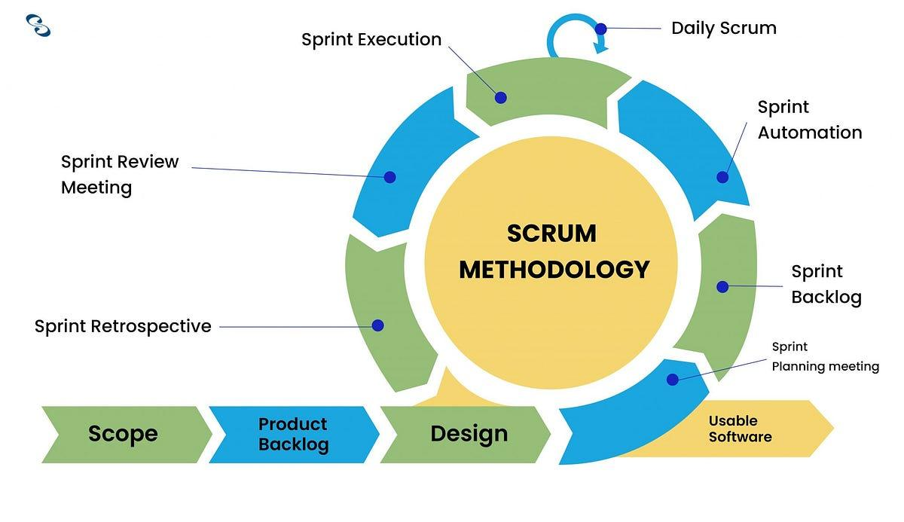

**SCRUM METHODOLOGY**

**FIGURE 2.1**

**Initiation.** The developers initiate the project to digitize the management of the organization (SOECS Department) which aims to automate and digitalize the activities, attendance, clearance, and financial administration including sanctions.

**Planning and Estimation.** In this phase, the developers plot the planned timelines for the milestones slated to be achieved. This involves a comprehensive examination of each milestone's scope and interdependencies within the project framework. The researchers will also develop a detailed roadmap delineating the sequence of milestones and their corresponding timeframes.

**Implementation.** During this phase, the researchers transition from planning and estimation to active implementation of all outlined plans and estimations. It marks the pivotal moment when anticipated timelines are translated into concrete progress.

**Reviewing.** This phase is where the researchers review the results of the completed sprints and backlogs. This is also where the researchers can brainstorm ideas for further improvement in the system.

**Releasing.** This final stage is where the researchers launch the system for the organization to be able to use for production.

**Purpose, Deliverables, and Development Activities**

**Table 1: Activities of Scrum Methodology**

|  |  |  |  |
| --- | --- | --- | --- |
| **Scrum Method** | **Purpose** | **Deliverables** | **Development Activities** |
| **Initiation** | Describe the primary aims and targets of the project. | The project's objectives, documentation, and outline. | Organize brainstorming meetings, conduct user research, and analyze findings. |
| **Planning and Estimation** | Create a thorough plan outlining the project's creation and implementation. | Acceptance criteria, user stories, and project strategy. | Establish the project's scope, make a work breakdown structure, and calculate the time and materials required. |
| **Implementation** | Create and evaluate the project. | Functional digitalized management system. | Create features, write code, and carry out pilot testing. |
| **Reviewing** | A digitalized management system that is functional. | Documentation and progress reports for projects. | Identify what to improve, get input from the SOECSS, and conduct sprint reviews and retrospectives. |
| **Releasing** | Releasing of the project. | Deployed digitalized management system | Set up the program for production, upload it to a local service, and promote it to potential users. |

**DATA GATHERING TECHNIQUES**

**Interview.** This technique is used to gather the necessary data from the identified respondents, the President, Secretary, Treasurer/Auditor, and Adviser of the LICOES Organization. Further, this technique will be used to know the problems and processes of the Organization when using the existing system. Using this technique in data gathering, the researchers understand their thoughts, and challenges as officers in their respective tasks and roles. This process is essential for gaining insights into what needs to be addressed as well as what methods are appropriate to implement in the proposed system.

**Observation.** The researchers are also students that belongs to the SOECS Department, they will be able to use their experiences with the current system when developing the proposed system. This observation will provide valuable insights into the problems and processes from the students perspective.

**Documentation.**

**SOURCES OF DATA**

**LICOES PRESIDENT.** We interviewed the CSIT president to inquire about the problems and the overall process of managing the organization.

**LICOES TREASURER.** The treasurer is in charge of the financial administration of the organization. Interviewing the treasurer provided the researchers with all the data needed in regard to the process and problem of managing the financial administration of the SOECS.

**LICOES SECRETARY.** The Secretary is involved in the administrative tasks of the organization

**SURVEY/INTERVIEW RESULTS**

|  |  |  |  |
| --- | --- | --- | --- |
| **Interviewee** | **Position** | **Interview Topic** | **Sample of Respondent’s Testimony** |
| **1** | **LICOES**  **President** | Process of the Management of Organization | The current system uses paper for storing the data, and then transferred to excel or google drive. |
| **2** | **LICOES Secretary** | Process of the Management of Organization | When it comes to clearance and sanction, the student must be cleared with their respective organization, not just the LICOES. |
| **3** | **LICOES Treasurer** | Process of the Financial Administration | The collection and storing of data is the main task of the treasurer. |

**Table 1.  
 Process of Managing the Organization**

The table 1 (Process of Managing the Organization) discusses the process of the organization when it comes to management tasks. Based on the testimony of the SOECS officers, it mostly contains how the management tasks work when it comes to the manual/traditional system that the organization uses.

|  |  |  |  |
| --- | --- | --- | --- |
| **Interviewee** | **Position** | **Interview Topic** | **Sample of Respondent’s Testimony** |
| **1** | **LICOES President** | Problems Faced when Managing the Organization | The problem with the current system is the data storage and how the organization collects data. |
| **2** | **LICOES Secretary** | The Problems Faced when managing the organization | It is hard |
| **3** | **LICOES Treasurer** | Problems of the Financial Administrative Task of the Organization | The financial administration also includes other organizations if that organization asked for help. So the |

**Table 2.  
 Problems of Managing the Organization**

Table 2 (Problems of Managing the Organization) is about the problems faced by the organization when it comes to different managerial tasks. Based on the respondent’s testimony, the problems came from the manual process of how they do the tasks.

**THEORETICAL FRAMEWORK**

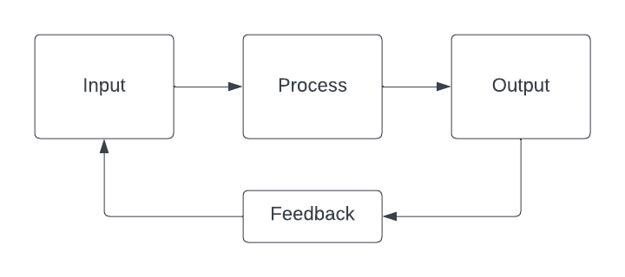

**Figure 2.2**

**System Theory**

The systems theory of management asserts that an organization is a unified system of interrelated parts or subsystems, each dependent on the others for optimal function. Changes in one part affect the whole, requiring a holistic approach to management. This theory highlights the need for integration, coordination, and feedback mechanisms to ensure the organization adapts and improves continuously.

In developing the Automated Management System (AMS) for SOECS, Systems Theory will guide the integration of different organizational functions into a cohesive automated system. The AMS will facilitate feedback loops through automated data collection and reporting, enabling continuous improvement. By automating management processes, the system will enhance coordination, efficiency, and adaptability across SOECS.

**CONCEPTUAL FRAMEWORK**

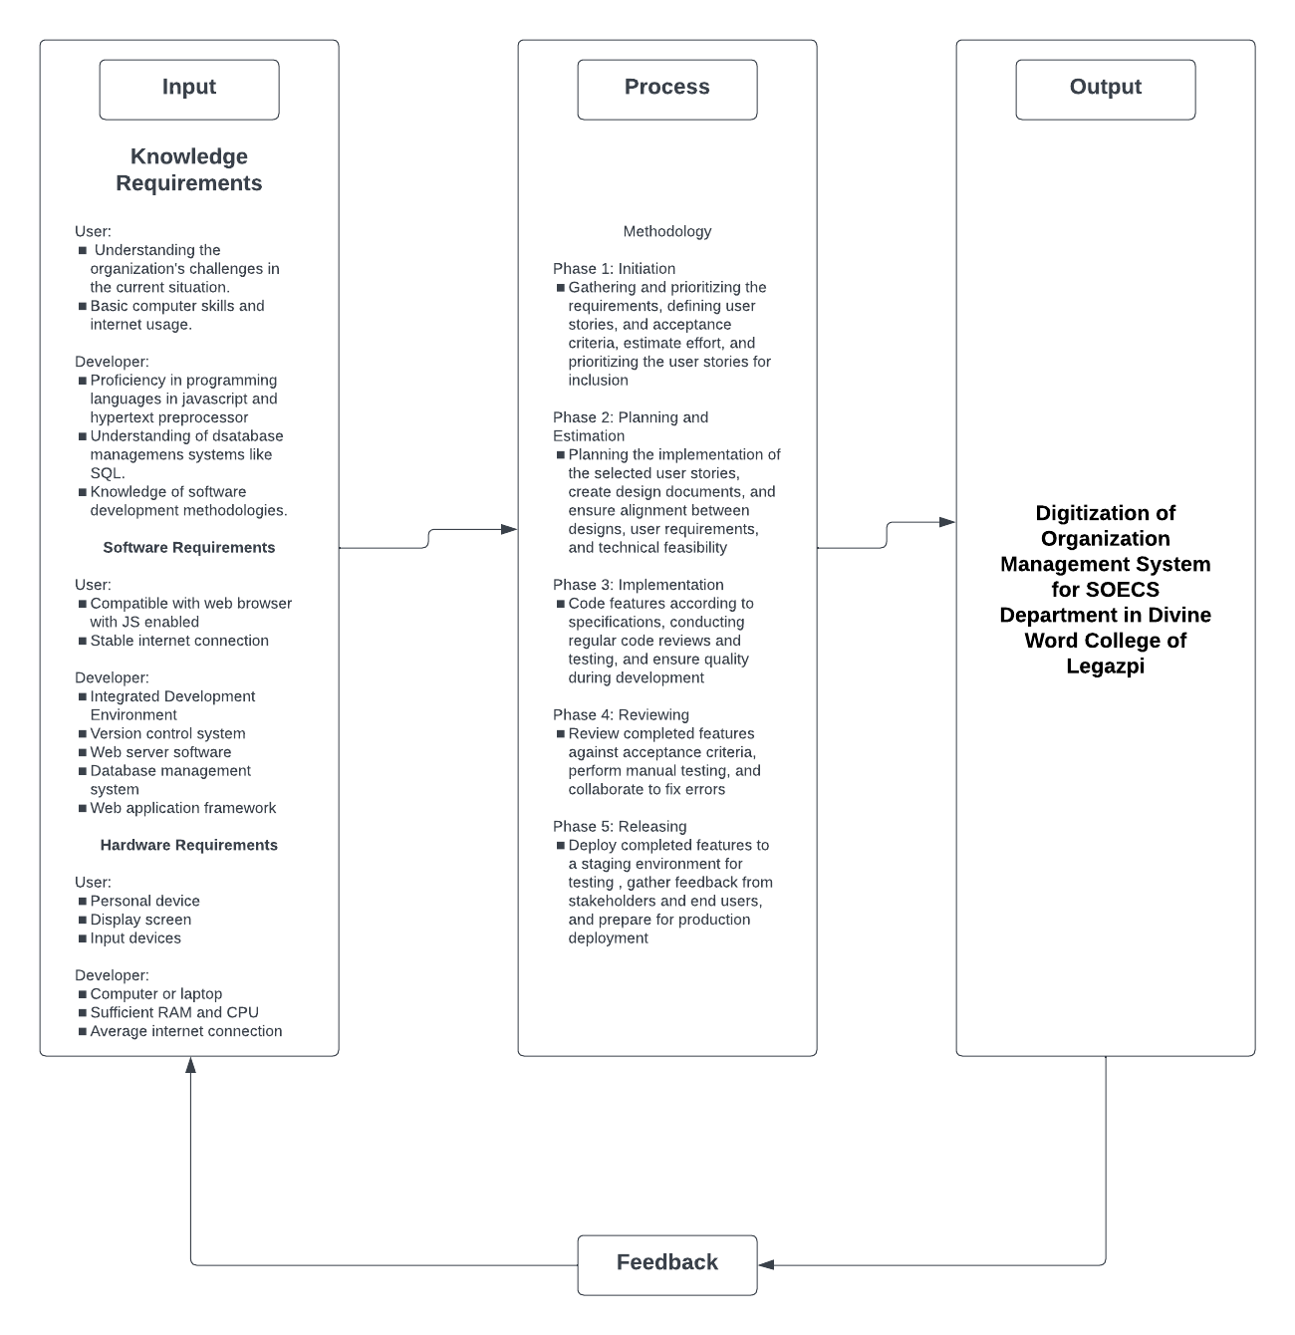

**Figure 2.3**

**Conceptual Framework**

The input for the Digitization Management System for the SOECS Department in Divine Word College of Legazpi encompasses diverse knowledge, software, and hardware requirements. Users need an understanding of the current situation of the organization, along with basic computer skills and internet access. Developers, on the other hand, require proficiency in programming languages, database management systems, and software development methodologies. Software requirements include a compatible web browser with JavaScript enabled and a stable internet connection for users, while developers need tools like IDEs, version control systems, and web server software. Hardware necessities range from personal computers and mobile devices for users to adequate computing resources and high-speed internet for developers. Feedback is essential for refining our system, ensuring that user needs are met and the platform remains functional and user-friendly.

**NOTES:**

Indeed Editorial Team.(2022).”5 Scrum Phases for Project Management (Plus

Benefits)”.Indeed. https://www.indeed.com/career-advice/career-development/scrum-phases

Marikyan, D. & Papagiannidis, S. (2023) Technology Acceptance Model: A review. In

S. Papagiannidis (Ed), TheoryHub Book. https://open.ncl.ac.uk/theories/1/technology-acceptance-model/

Tokay Korkut.(2023).”Excelling in Software Development with Scrum Methodology

Part 2”.Stackademic. https://blog.stackademic.com/excelling-in-software-development-with-scrum-methodology-part-2-e2d0b29437ce

**CHAPTER III**

**REQUIREMENTS ANALYSIS AND DOCUMENTATION**

The requirements analysis and documentation showcased various visual representations such as flowcharts and system architectures, alongside detailed explanations like use case, class, and sequence diagrams. Additionally, it encompassed tables for database design, system requirements, trade-offs, and project timelines, as well as statistical tools.

**FLOWCHART**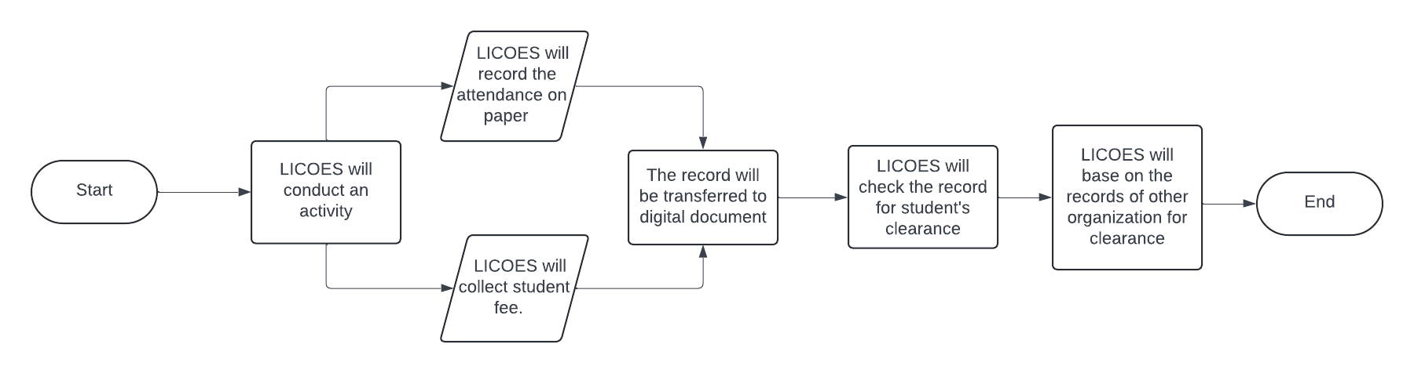

**Figure 3.1 Flowchart of Organization Management System of SOECS Department**

This flowchart illustrates the manual process followed by SOECS when managing the organization when it comes to five managerial tasks. Attendance and financial administration are the requirements for the students to have their clearance signed. If they did not attend the activity or paid their membership fee they will get a sanction and they will not get their clearance signed by the president and adviser.

**SYSTEM ARCHITECTURE**

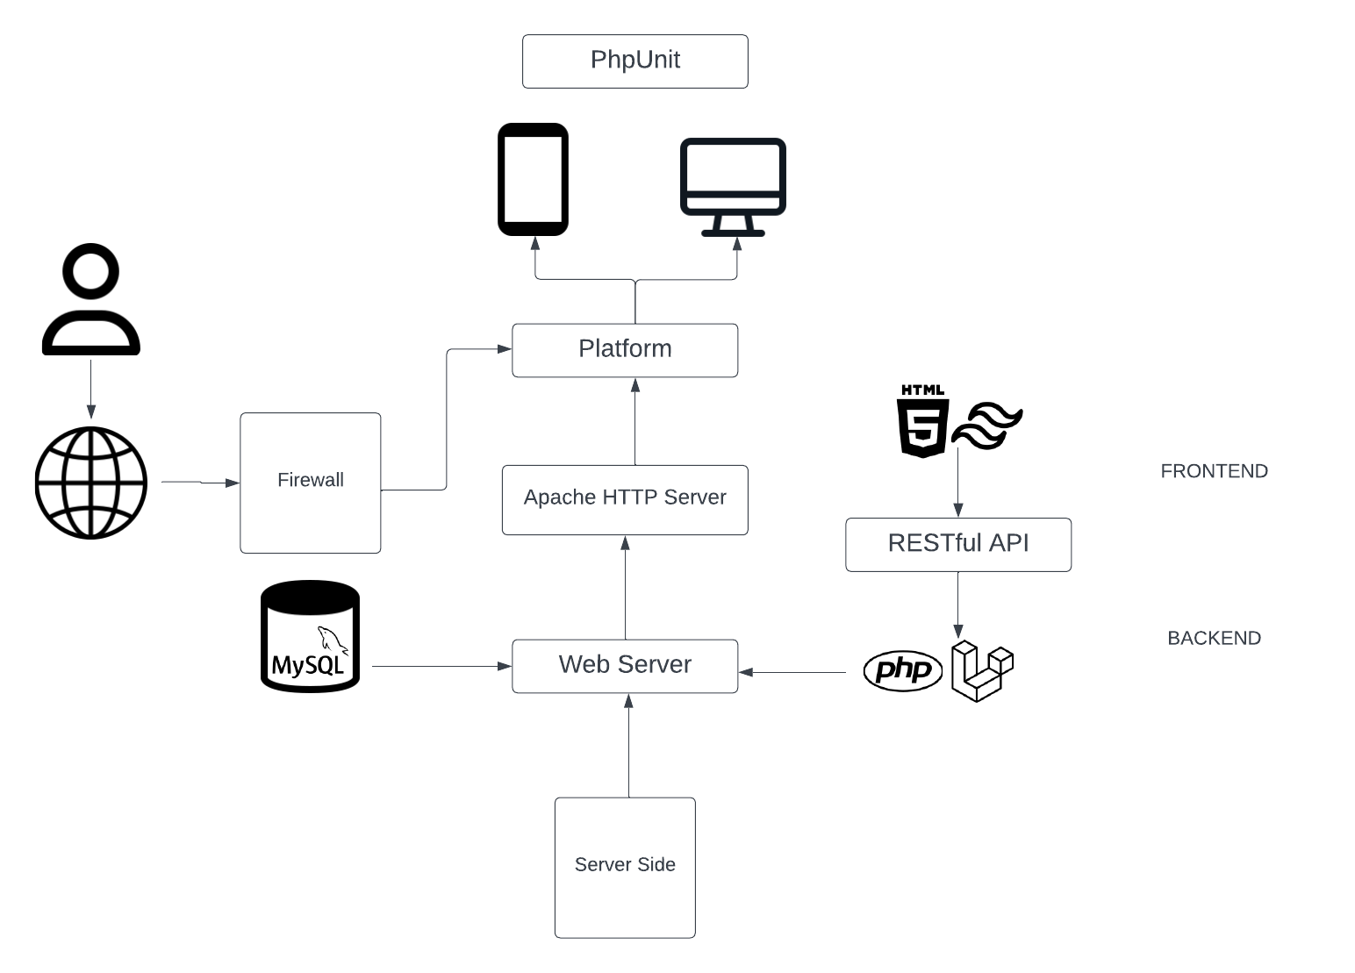

**Figure 3.2. System Architecture**

The developers will be using HTML and CSS Framework (Tailwind) for the front end of the web application. The backend will involve PHP as the language for the server side and the PHP framework (Laravel). To connect the frontend and the backend the developers will use RESTful API for fast integration. We will also use MySQL Database for data storage,

**SOFTWARE DESIGN**

Include UML (Unified Modeling Language) figures in this section such as the Use Case Diagram, Sequence, and Class Diagram of the proposed system. Discuss the flow of each figure.

**USE CASE DIAGRAM**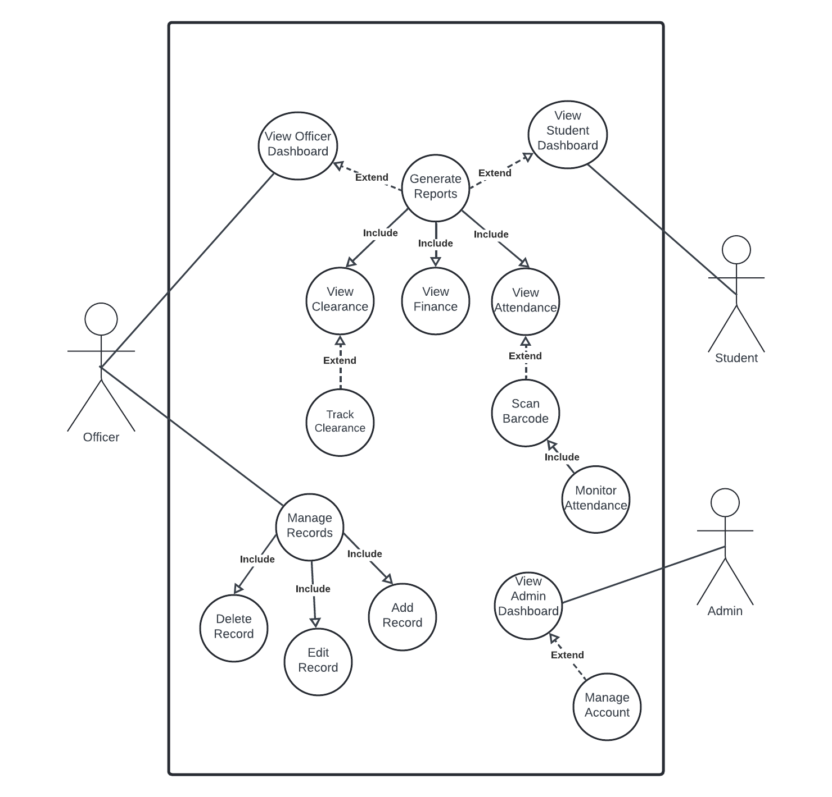

**Figure 3.3 Use Case Diagram**

The Use Case Diagram (Figure 3.3) illustrates how students and officers interact with the system. Students can only view attendance, financial status, and clearance. Officers can post and edit in activity and sanction webpages. For financial administration they can input data, and for clearance they can only view. In attendance they can generate QR Code for the scanning of students.

**Sequence Diagram**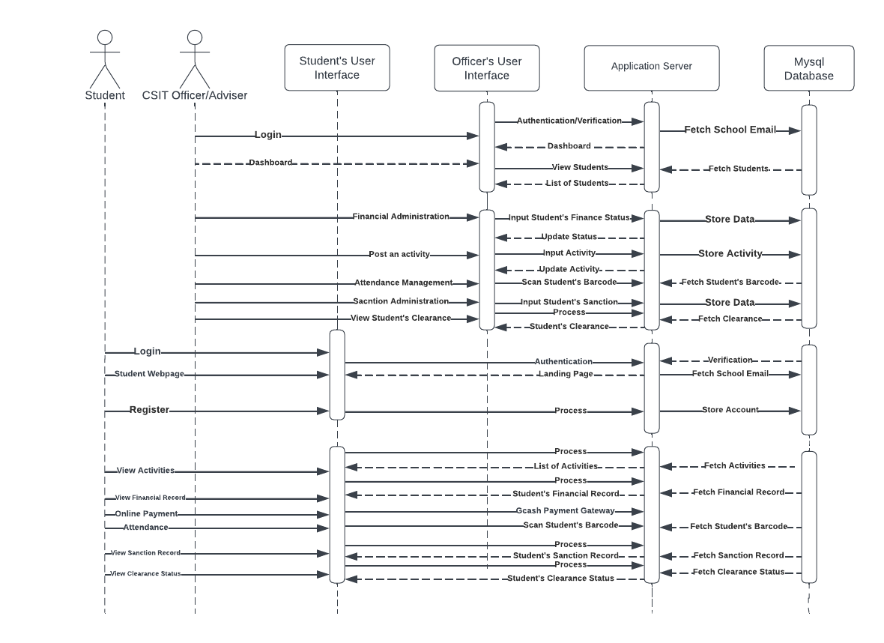

**Figure 3.4 Sequence Diagram**

The figure 3.4 sequence diagram shows the actions available to each user role and collaborative elements within the system. Initially, the student logs in, passing through authentication and verification. Once authenticated, the system displays the home page for the student .They are able to view past and upcoming activities, their financial, sanction and clearance status. If there is an activity, the student will take an attendance through the website and scan the QR Code. The system records the time in and time out, displays results, and enables the student to view them.

**Class Diagram**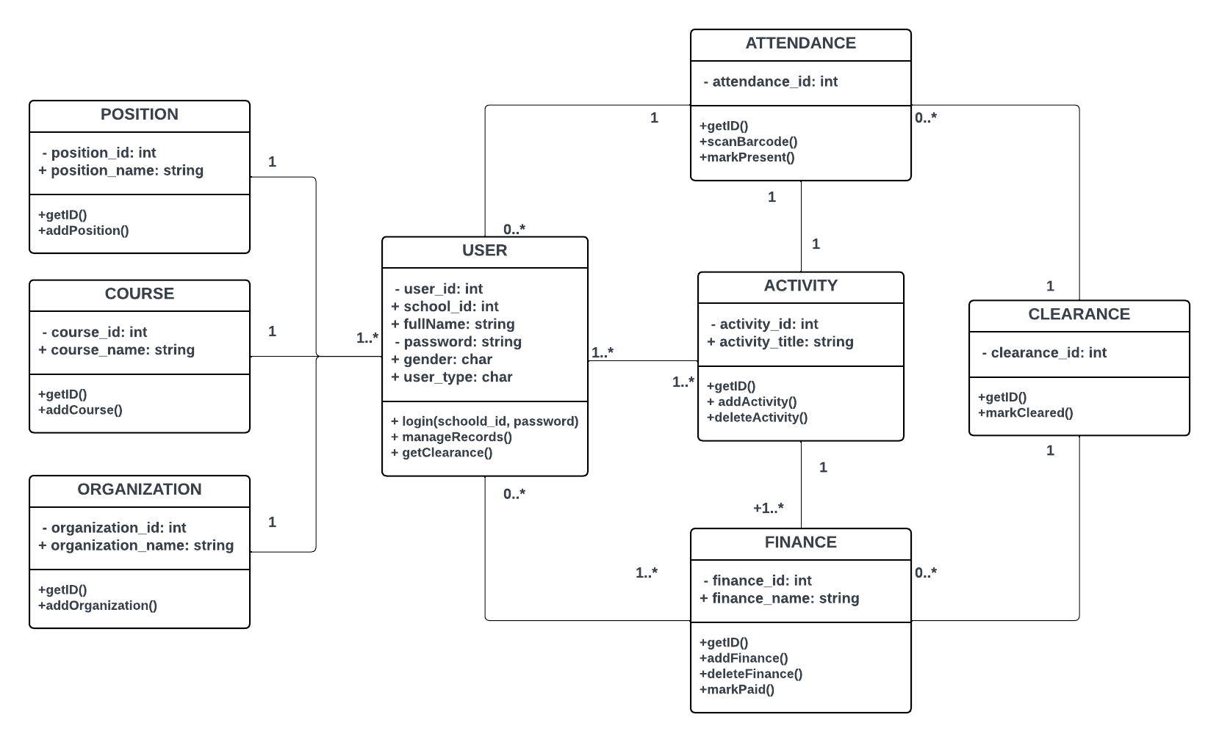

**Figure 3.5 Class Diagram**

The Class Diagram (Figure 3.5) discusses the relationship between the system’s database elements. Each table has

**DATABASE DESIGN**

**1st Normal Form**

Table 3.1 Un-normalized Table

|  |  |  |  |  |
| --- | --- | --- | --- | --- |
| user_id | school_id_no. | user_name | course | organization_name |
| password | phone_number | user_type | address | organization_id |
| attendance_id | activity_id | student_id | semester | position_name |
| finance_id | finance_name | year_level | role_id | sanction_name |
| sanction_id | clearance_id | sanction_id | time_in | attendance_id |
| status_id | status_name | role_name | time_out | position_id |

Table 3.2 Normalized User’s Table

|  |  |  |  |  |  |
| --- | --- | --- | --- | --- | --- |
| user_id | school_id_no. | full_name | course | year_level | address |

Table 3.5 Normalized Position’s Table

|  |  |
| --- | --- |
| position_id | position_name |

Table 3.6 Normalized Organization’s Table

|  |  |
| --- | --- |
| organization_id | organization_name |

Table 3.7 Normalized Status Table

|  |  |
| --- | --- |
| status_id | status_name |

Table 3.8 Normalized Activity’s Table

|  |  |  |
| --- | --- | --- |
| activity_id(PK) | organization_id(FK) | activity_title |
| activity_desc | semester | year |

Table 3.9 Normalized Attendance Table

|  |  |  |
| --- | --- | --- |
| attendance_id(PK) | activity_id(FK) | student_id(FK) |
| time_in | time_out | status_id(FK) |

Table 3.10 Normalized Finance Table

|  |  |  |
| --- | --- | --- |
| finance_id(PK) | finance_name | student_id(FK) |
| semester | year | status_id(FK) |

Table 3.12 Normalized Clearance Table

|  |  |  |
| --- | --- | --- |
| clearance_id(PK) | sanction_id(FK) | student_id(FK) |
| semester | year | status_id(FK) |

**SYSTEM REQUIREMENTS**

**HARDWARE REQUIREMENTS**

In order for the suggested system to operate optimally, it is crucial to have appropriate hardware in place. Here, we detail the essential hardware components and their specifications. Meeting these criteria guarantees seamless functionality and dependable access to the system's capabilities, thereby enhancing user tasks with increased efficiency and ease.

**Recommended Server Hardware Specifications**

|  |  |
| --- | --- |
| **Required Hardware** | **Specifications** |

**Server**

|  |  |
| --- | --- |
| **OS** | Windows 10 or higher |
| **CPU** | Intel core i5 2.20 GHz base speed |
| **Disk** | 120GB SSD/HDD |
| **RAM** | 16 GB SODIMM/DIMM |
| **Network Speed** | 50/100 Mbps |

**Recommended Client Hardware Specifications**

|  |  |
| --- | --- |
| **Required Hardware** | **Specifications** |

**Client**

|  |  |
| --- | --- |
| **OS** | Windows 10 or higher |
| **CPU** | Intel core i5, 1.5oGHz base speed |
| **Disk** | 120GB SSD/HDD |
| **RAM** | 8 GB SODIMM/DIMM |
| **Network Speed** | 50 Mbps |
| **Inputs** | Keyboard & mouse for PC/Laptop  Touchscreen for mobile devices |

The server hardware specifications presented in our system's table outline crucial details necessary for ensuring smooth operation and peak performance of the platform. Designed to be compatible with Windows 10 and above, these specifications cater to a wide user base familiar with this operating system, ensuring seamless functionality within the Windows environment. Equipped with an Intel Core i5 processor running at a base speed of 2.20 GHz and featuring a quad-core setup, the server efficiently manages processing requirements. A minimum storage capacity of 120 GB on SSD/HDD guarantees ample space for data storage and retrieval, while 16 GB of RAM supports seamless multitasking and responsiveness. Moreover, a network interface offering 50/100 Mbps connectivity ensures fast and reliable communication between the server and client devices, optimizing performance for users accessing our system's features and services.

On the client side, our system's requirements are tailored to ensure optimal performance and accessibility across a variety of devices. A recommended dual-core processor clocked at 1.50 GHz or higher ensures efficient handling of computational tasks, while a minimum storage capacity of 120GB on SSD/HDD and 8 GB of RAM provide sufficient space and memory for storage-intensive applications. A broadband internet connection with a speed of at least 50 Mbps is vital for seamless communication with our server, facilitating smooth access to its features and functionalities. Furthermore, our system supports various devices, including PCs and laptops, offering users flexibility and convenience in accessing the platform.

**SOFTWARE REQUIREMENTS**

The software requirements encompass essential components necessary for developing a system. These include a programming language for coding, a framework for constructing user interfaces, and a database for storing application data.

**Recommended Software Specifications**

|  |  |
| --- | --- |
| **Particulars** | **Specifications** |
| Language | PHP, CSS, and JS |
| Framework | Laravel & Tailwind |
| Database | MySQL |

The software requirements encompass PHP, HTML, CSS, and JS for coding, utilizing Laravel & Tailwind framework for constructing user interfaces, and MySQL for storing application data. These tools will offer an efficient and flexible environment for developing our system tailored to the researchers' needs.

**SYSTEM TRADEOFFS** During the development and implementation of our system, it's crucial to weigh different tradeoffs, taking into account technical, operational, and economic aspects. These tradeoffs necessitate decisions that strike a balance between conflicting priorities to efficiently attain the desired results.

|  |  |
| --- | --- |
| **Technical Issues** | **Trade-Offs** |
| Performance | The system requires a CPU speed of 1.50GHz or higher with 8 - 16 GB RAM |
| Deployment | The system must be compatible with the web server to facilitate access and usage across different platforms and devices |
| Operational Characteristics | For optimal efficiency and compatibility with development tools, the primary environment for development should be Windows 10, utilizing an Intel Core i5 processor. |
| Interoperability with Other Technologies | To enrich functionality and offer a comprehensive user experience, the system should seamlessly integrate with technologies such as VS Code, Git, and MySQL Workbench. |

In navigating our system's technical landscape, several tradeoffs are important to consider. Performance-wise, ensuring smooth operation and responsiveness necessitates a CPU speed of at least 1.50GHz paired with 8-16GB of RAM to accommodate peak usage periods effectively. Deployment is contingent upon compatibility with web servers and applications, enabling widespread accessibility across various platforms and devices. Operational efficiency is optimized by prioritizing development within a Windows 10 environment, utilizing an Intel Core i5 processor for seamless integration with development tools. Additionally, interoperability with technologies like VS Code, Git, and MySQL Workbench enhances functionality, fostering a comprehensive user experience and facilitating seamless integration with other systems and services.

**Operational Issues**

|  |  |
| --- | --- |
| **Operation Issues** | **Trade-Offs** |
| Support Tools | Laravel 10, MySQL, Git 2.42.0.2 |
| User and Developer Skills | Proficiency in PHP and HTML is essential to leverage Laravel effectively for system development, alongside Git for version control and collaborative work among researchers, and MySQL for database management. Additionally, expertise in Tailwind and JavaScript is required for creating intricate and responsive front-end designs. |
| Processes | Design a plan outlining the structure and functionality of the software. Implement development using Laravel with PHP, utilize Git for version control and package management, and employ MySQL for data sorting and management. Execute thorough testing to identify and resolve bugs and issues within the system. |
| Documentation | Exploring alternative platforms and analyzing their functionalities and effectiveness among users. |

|  |  |
| --- | --- |
| **Economic Issues** | **Trade-Offs** |
| Hardware and Software Updates | The system's performance would be optimal with an internet speed of at least 100 Mbps. |
| Development Costs | Utilizing the Laravel Framework and MySQL for database management in the proposed system eliminates the need for additional development expenses. |
| Operational Costs | The estimated cost for this project is Php 3,000.00  The breakdown is:   * Food Php 1,000.00 * Bond paper Php 600.00 * Printing Php 500.00 * Miscellaneous Php 900.00 |
| Training Cost |  |

**System Design**

The system design phase outlines the architecture and specifications necessary to meet the functional and non-functional requirements of our system. This phase focuses on structuring the system to ensure optimal performance, usability, and reliability. By defining the system's components, interactions, and constraints, the design lays the foundation for the development and implementation stages.

**Functional Requirements**

|  |  |  |
| --- | --- | --- |
|  | **Properties** | **Constraints** |
| System | The system should allow users to access financial information, activities, attendance records, and clearance status. | The system may require specific hardware configurations, such as a compatible web browser and adequate processing power, to ensure optimal performance. |
| User | The system should provide a user-friendly interface featuring intuitive controls and clear navigation to improve the overall user experience. | Users might need training sessions or access to documentation to acquaint themselves with the features and functionalities of our system efficiently. |
| Software | The software depends on consistent internet connectivity to function properly, guaranteeing uninterrupted access to its features and capabilities. | The system should support a range of devices and operating systems to cater to diverse user preferences and ensure broad accessibility. |
| Service | The system should be accessible 24/7, enabling users to utilize it at any time without interruptions. | The system must incorporate security measures such as data encryption and user authentication to safeguard sensitive information and uphold user privacy. |

The non-functional requirements table delineates essential properties and constraints for our system, encompassing system, software, user, and service aspects. Our system is expected to provide seamless access to various user documents, including financial information, activities, attendance records, and clearance status. It must prioritize user experience by offering an intuitive interface and ensuring round-the-clock availability for uninterrupted usage.

Constraints within our system may necessitate specific hardware configurations, such as compatible web browsers and adequate processing power, to ensure optimal performance. Additionally, users may require training sessions or access to documentation to effectively familiarize themselves with the system's functionalities. Software constraints dictate the dependency on stable internet connectivity for seamless operation and broad accessibility across devices and operating systems. Service constraints mandate the implementation of security measures, including data encryption and user authentication, to protect sensitive information and maintain user privacy.

**Functional Requirements**

|  |  |  |  |  |
| --- | --- | --- | --- | --- |
| **Input** | **Process** | **Output** | **Storage** | **Control** |
| User information (username, school email, password) | Verify user details for accuracy. | Store the user details in the database. | MySQL Database | Administrator/Registration |
| Username, password | Authenticate and | Log in with the session, and redirect to the respective landing page. | Request and query for user’s input authenticity to confirm if the user exists. | Admin/User |
| Attendance | The student will time in and time out for attendance. | Status and time if the student has attended | Fetch barcode from | Administrator/Officer/User |
| Financial Administration | The officer will collect membership fees/other fees and store the data in the database. | Display the status if the student membership fee is paid or not yet paid. | Store the data in the database for input and fetch for display. | Officer/User |
| Activities | Officers will post an announcement with the details of the activity. | Display the details of the activity on the student’s webpage. | Store the data in the database for input and fetch for display. | Officer/User |
| Sanction | Officers will input the student’s sanction details and status. | Display the details of the student’s sanction on each student’s account. | Store the data in the database for input and fetch for display | Officer/User |
| Clearance | The system will be based on the sanction status of the student. | The student will view their clearance status. | Fetch the data from sanction and display the clearance status | User |

The data displayed on the functional requirements are the functions that must be implemented in the Organization Management System. This includes the input, process, output, storage of data, and who is in control of the five management tasks.

**PROJECT TIMELINE**

|  |  |  |  |  |  |  |  |  |  |  |  |  |  |  |  |  |  |  |  |  |  |  |  |  |  |  |  |  |
| --- | --- | --- | --- | --- | --- | --- | --- | --- | --- | --- | --- | --- | --- | --- | --- | --- | --- | --- | --- | --- | --- | --- | --- | --- | --- | --- | --- | --- |
| **Activities** | **Jan** | | | | **Feb** | | | | **Mar** | | | | **Apr** | | | | **May** | | | | **Jun** | | | | **Jul** | | | |
| 1 | 2 | 3 | 4 | 1 | 2 | 3 | 4 | 1 | 2 | 3 | 4 | 1 | 2 | 3 | 4 | 1 | 2 | 3 | 4 | 1 | 2 | 3 | 4 | 1 | 2 | 3 | 4 |
| **Initiation** |  |  |  |  |  |  |  |  |  |  |  |  |  |  |  |  |  |  |  |  |  |  |  |  |  |  |  |  |
| Interview |  |  |  |  |  |  |  |  |  |  |  |  |  |  |  |  |  |  |  |  |  |  |  |  |  |  |  |  |
| **Planning and Estimation** |  |  |  |  |  |  |  |  |  |  |  |  |  |  |  |  |  |  |  |  |  |  |  |  |  |  |  |  |
| Assigning roles to members. Choosing language, database and frameworks. |  |  |  |  |  |  |  |  |  |  |  |  |  |  |  |  |  |  |  |  |  |  |  |  |  |  |  |  |
| Planning the flow of the website and the features to add. |  |  |  |  |  |  |  |  |  |  |  |  |  |  |  |  |  |  |  |  |  |  |  |  |  |  |  |  |
| Wireframe |  |  |  |  |  |  |  |  |  |  |  |  |  |  |  |  |  |  |  |  |  |  |  |  |  |  |  |  |
| Finalize front-end design |  |  |  |  |  |  |  |  |  |  |  |  |  |  |  |  |  |  |  |  |  |  |  |  |  |  |  |  |
| Finalize database schema |  |  |  |  |  |  |  |  |  |  |  |  |  |  |  |  |  |  |  |  |  |  |  |  |  |  |  |  |
| **Implementation** |  |  |  |  |  |  |  |  |  |  |  |  |  |  |  |  |  |  |  |  |  |  |  |  |  |  |  |  |
| Development of front-end |  |  |  |  |  |  |  |  |  |  |  |  |  |  |  |  |  |  |  |  |  |  |  |  |  |  |  |  |
| Implement back-end |  |  |  |  |  |  |  |  |  |  |  |  |  |  |  |  |  |  |  |  |  |  |  |  |  |  |  |  |
| **Testing** |  |  |  |  |  |  |  |  |  |  |  |  |  |  |  |  |  |  |  |  |  |  |  |  |  |  |  |  |
| Integration Testing |  |  |  |  |  |  |  |  |  |  |  |  |  |  |  |  |  |  |  |  |  |  |  |  |  |  |  |  |
| Pilot Testing |  |  |  |  |  |  |  |  |  |  |  |  |  |  |  |  |  |  |  |  |  |  |  |  |  |  |  |  |
| **Deployment** |  |  |  |  |  |  |  |  |  |  |  |  |  |  |  |  |  |  |  |  |  |  |  |  |  |  |  |  |
| **Review** |  |  |  |  |  |  |  |  |  |  |  |  |  |  |  |  |  |  |  |  |  |  |  |  |  |  |  |  |
|  |  |  |  |  |  |  |  |  |  |  |  |  |  |  |  |  |  |  |  |  |  |  |  |  |  |  |  |  |

Table 5: Organization Management System Gantt Chart using SCRUM Methodology

The proposed system follows the SCRUM methodology, and the five phases of this methodology clearly illustrate the progress of the system. We begin with planning and attain a deeper understanding of what the system needs. The next step is to design the user interface and the database schema. Next, is to develop and implement the designed user interface and database. After that, we built the actual system through coding and testing. Next, is to deploy the system to the public and gather reviews from the users.

**RECOMMENDATION FOR CAPSTONE PROJECT FINAL DEFENSE**

In partial fulfillment of the requirements for the degree Bachelor of Science in Information Technology, this Capstone Project entitled, **‘AUTOMATED ORGANIZATION MANAGEMENT SYSTEM FOR SOCES”** prepared by **Arvin G. Milan** and **Edwin Erick I. Borlasa** is hereby submitted to the Capstone Project Committee for consideration and approval.

**EMMANUEL ISAIAH Z. DETERA**

Adviser

In partial fulfillment of the requirements for the degree Bachelor of Science in Information Technology, this Capstone Project entitled, **‘AUTOMATED ORGANIZATION MANAGEMENT SYSTEM FOR SOCES”** prepared by **Arvin G. Milan** and **Edwin Erick I. Borlasa** is hereby considered and endorsed for Final Defense.

**RHODORA FAYE A. BROSAS, MBA, MIT**

Capstone Project Coordinator

**RESULT OF THE FINAL DEFENSE**

**Project Title :** AUTOMATED ORGANIZATION MANAGEMENT

SYSTEM FOR SOECS

**Researchers : Arvin G. Milan Edwin**

**Erick I. Borlasa**

**Place:** Room 315 **Date:** September 28, 2024 **Time: 12:30 pm**

FINAL DEFENSE COMMITTEE ACTION TAKEN

**JP Remar Serrano**  __________________

Panel Member

**Reilan Cadubla** __________________

Panel Member

**EMMANUEL ISAIAH Z. DETERA**

Adviser

**RHODORA FAYE A. BROSAS, MBA, MIT**

Capstone Project Coordinator

**CAPSTONE PROJECT 2 COMPLETION**

**Project Title :** AUTOMATED ORGANIZATION MANAGEMENT

SYSTEM FOR SOECS

**Researchers : Arvin G. Milan Edwin**

**Erick I. Borlasa**

**Degree Program :** Bachelor of Science in Information Technology

Final Defense Completed On: September 28, 2024

CAPSTONE PROJECT COMMITTEE

FINAL DEFENSE COMMITTEE ACTION TAKEN

**JP Remar Serrano**  __________________

Panel Member

**Reilan Cadubla** __________________

Panel Member

**EMMANUEL ISAIAH Z. DETERA** __________________

Adviser

**RHODORA FAYE A. BROSAS, MBA, MIT**

Capstone Project Coordinator

**CERTIFICATE OF APPROVAL**

This is to certify that the Capstone Project of:

**ARVIN G. MILAN**

**EDWIN ERICK I. BORLASA**

has been approved by the Capstone Project Committee in partial fulfillment of the requirements of the degree of Bachelor of Science in Information Technology School of Engineering and Computer Studies

EMMANUEL ISAIAH Z. DETERA  
Adviser

**RHODORA FAYE A. BROSAS, MBA, MIT**

Capstone Project Coordinator

**ENGR. MARBEN S. RAMOS, LPT**

OIC - DEAN

**EXECUTIVE SUMMARY**

**Project Title :** AUTOMATED ORGANIZATION MANAGEMENT

SYSTEM FOR SOECS

**Researchers : Arvin G. Milan Edwin**

**Erick I. Borlasa**

**Keywords :** Generate Reports, Record Management, Attendance

Monitoring, Clearance Tracking,

Organization Management